St. Aloysius Secondary School
Sharman Crawford Street,
Cork.

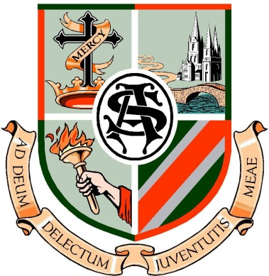

Annual Report 2014 – 2015

Contents
Mission Statement
What We Treasure
Board of Management
Staff
Parents’ Association
Student Leadership
Faith Development
Academic Excellence
Co-curricular
Extra-Curricular
Charity
Resource Management and Development
Finance
Ongoing Professional Development
Student Care
Special Needs Education
Learning Support
Information Technology
Pastoral Care
Positive Behaviour
Sample Curriculum
Sample 1st year timetable
Thank You
Declaration
Album

Mission Statement-taking the reality of CEIST into account

St. Aloysius School is a Catholic School founded by the Mercy Order. It has a long tradition of academic excellence and is committed to the development of the whole student.
It offers a curriculum designed to meet the needs of the student. The school wishes to cater for the academic, interpersonal and physical needs of the student.

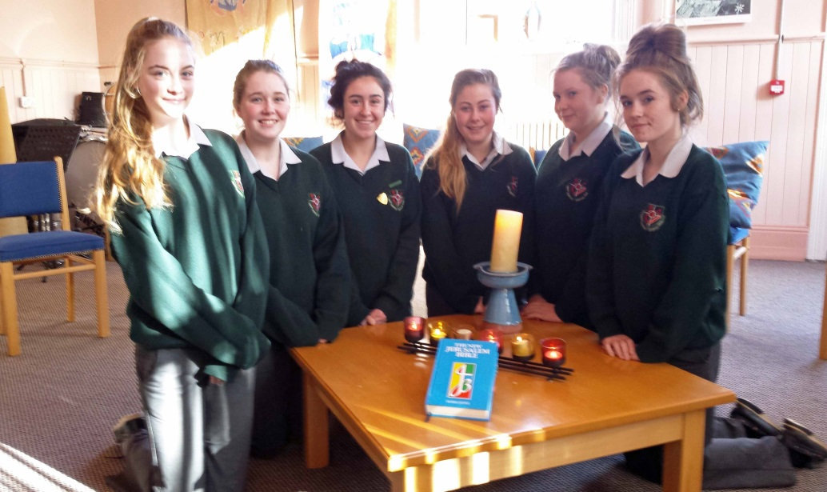

What we in St. Aloysius treasure: Our CEIST Charter

Promoting Spiritual and Human Development: We believe a knowledge of and a personal relationship with Jesus Christ give meaning and purpose to our lives.

Achieving Quality in Teaching and Learning: We are committed to excellence and to continually improving the quality of teaching and learning.

Showing Respect for Every Person: We respect the unique and intrinsic value of every person.

Creating Community: Our schools are faith communities of welcome and hospitality where Gospel values are lived and where there is special care for those most in need.

Being Just and Responsible: We seek to act justly and responsibly in all our relationships.

Board of Management:

The Board met on eleven occasions during the academic year of 2014 – 2015.

Sr. Mercedes Desmond retired from the Board of Management in her 93rd year, having loyally served the school community of St. Aloysius as Principal, Manager and Board member. Sr. Mercedes Desmond came to St. Marie of the Isle convent in 1942 and her service to education was recognised on 2nd November 2015 by University College Cork in awarding an Honorary Doctorate of Education, to Sr. Mercedes Desmond for her exceptional service to education.

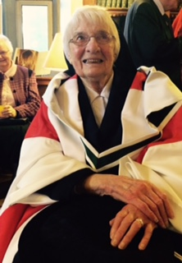

Mrs. Carmel Healy, Principal of St. Maries of the Isle primary school joined the Board as a Trustee nominee. Mrs. Sharon Hegarty joined as a parental nominee in September 2015.

At the January Board of Management meeting, The Child Protection Policy was ratified for the coming year and Ms. Richel Long, Principal was sanctioned as the Designated Liaison Person re Child Protection and Ms Eileen Kelleher, Deputy Principal, was sanctioned as the Deputy Designated Liaison person. The power of suspension for three days was delegated to Ms. Long.

The Board pledged particular attention to the areas of
1. Teaching & Learning,
2. Policy Development,
3. Finance
4. Plant Management.
The Board welcomed the very positive increase in student numbers and are committed to maintaining and building on the high standards in the school. The Board acknowledges the roles played by all members of the school community and thanks everyone who was involved in initiating, facilitating, organising or supporting the activities that take place on a daily basis and the sample outlined in this Annual Report.

Staff:
Our staff allocation from The Department of Education and Skills was just over 22 teachers consisting of Whole Time Equivalent Hours, Contract of Indefinite Duration hours, part-time hours and hours for Special Education Needs.

Parents’ Association:
The Parents’ Association was, once again, active in many areas. Despite a small attendance at the AGM this vibrant group represented the parents by:
• Reviewing school policies
• Fundraising
• Organising a successful social evening.
• Organising with the support of the Student Council a clothing drive.
As a result of their fundraising a cheque of €1000 was presented to the school for the replacement of student chairs.

Regular communications with parents include notifications:
• By phone and texts
• Individual meetings with parents
• Newsletter
• Website and Twitter
• Via Parents’ Association through the delivery of the Board of Management Agreed Report.
Other events for parents included:
• Information evening for 1st Year Parents
• CAO Presentation for 6th Year Parents
• Open Night
• Individual meetings for incoming students.
Student Leadership
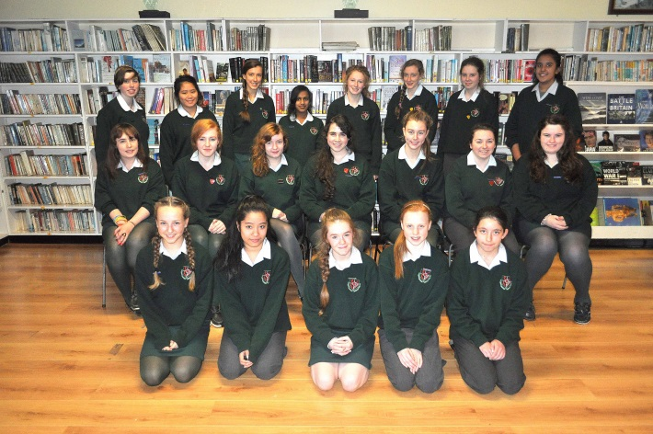
The Students’ Council met weekly. Work completed included:
• Presenting an end of year report to the Board of Management.
• Supporting the development of the mobile phone policy.

Attending student leadership competitions, such as Natmun, Rotary and Comhairle na nÓg.

•Organising a student lead survey into Homework in St. Aloysius. The student council embraced the School Self Evaluation model of the Department of Education and presented the student voice on homework to the Principal and Board of Management.

• Working with Mrs. Roche Cagney to erect a Student Council Board and to purchase some outside picnic benches and new whiteboards. The Student Council organized a monthly non uniform day, which helped raise over €3500 towards school funds. The Student Council gave €500 to the Hati earthquake disaster.

• Three students attended and presented at the inaugural CEIST Student Leadership Conference.

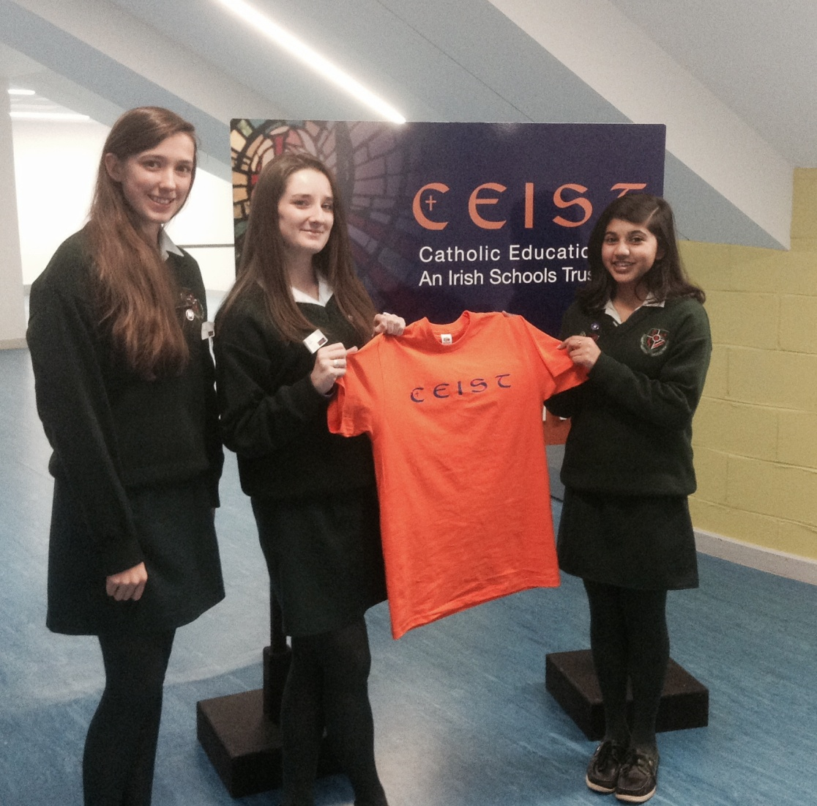

The work of the Student Council was complemented by the work of the Meitheal Leaders who took responsibility for the care of 1st Year students in the transition to secondary school and the Prefects, Deputy Head Girls and Head Girls who supported all the other students.

Meitheal is a youth leadership programme run by the Redemptorist community, providing young students with a unique opportunity to develop life skills in the areas of communication, teamwork, respect of others and honesty. In St Aloysius the Meitheal team compromise of fifth year students who have been selected through interview from members of the Redemptorist community.
By applying the skills and talents developed through the training programme of Meitheal, our first year students from various primary schools benefit enormously, helping create a first year group who are happier, integrated and respecting of each other.

This year our Meitheal members have been busy working very hard endeavouring to welcome our new school members, by organising lunchtime activities, cinema trip and the pizza party. Such hard work reflects the Meitheal team’s great commitment despite their very hectic timetable. Through their work, the Meitheal team reflect the words of the prophet Micah: Justice, Compassion and Humility.

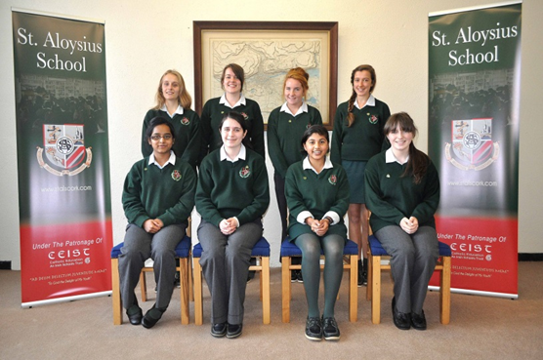

When school starts, the Meitheal role is to look after the incoming 1st year students by fostering friendships with and among the 1st years so as to reduce the likelihood of bullying occurrences as well as providing other valuable support. The programme aims to tackle difficulties at an early stage, to build self-confidence and a sense of responsibility for others. Meitheal aims to make school a better place in which to learn. The leaders are supported in their work by weekly meetings facilitated by staff.

Faith Development:

Our Religion Department supported by the Music department and Fr. Lynn, organised the liturgies and rituals central to the Faith Development of our school community:
- Mercy Day Mass
- November Prayers of Remembrance
- Christmas liturgy service
- St. Vincent de Paul Giving Tree, organized by the Student Council.
- Prayer service on 6th January Feast of The Epiphany
- Prayers during Catholic School Week
- Graduation Mass
- Trocáire Fast Lenten Campaign
- Junior Certificate Mass
- May the month of Mary alter
- SHARE collection and students servicing on the executive committee of SHARE.
- Meitheal team training in the La Scala Retreat Centre, Blackrock, Cork.
- Alter servers in the St. Maries of the Isle convent chapel.

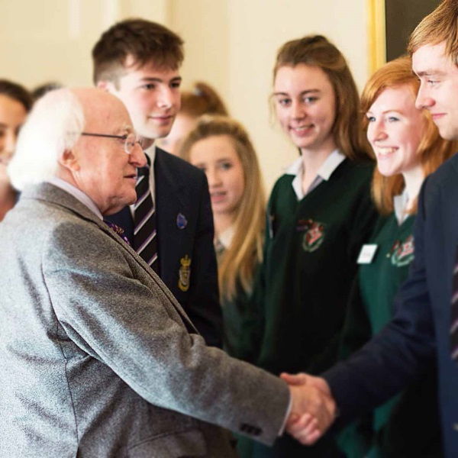

Academic Excellence:
The fundamentals of Teaching and Learning are evident in the day-to-day classroom interactions between students and teachers accompanied by the numerous other learning opportunities presented in co-curricular and extra-curricular activities. We set high standards and have high expectations for our students. Regular attendance is essential to maintain progress and the attendance rate was improved on 2013-2014.All attendance figures were reported to the Educational Welfare Services in TUSLA.

Academic achievement in 2014/15 was supported in a number of ways:
- Encouragement and challenge - evident in our Junior and Leaving Certificate results where the numbers sitting higher level subjects and achieving high grades are above the national average. Highlights this year include the d by the SEC as high achievers in German and offered summer scholarships.
- Career Guidance Dept. that gives one to one advice, organises information evenings and arranges trips to such places such as UCC, CIT, UL and the Career Options conference in Rochestown Cork.
- After School Study.
- UCC Quercus Scholarship winner: Ms. Aoibhinn Warner.
- Annual Award Ceremony: guest speaker was past pupil President of Irish Dentist Association, Dr. Anne Twomey.
- Mixed ability classes.
- Leaving certificate class of 2013succeed in reaching a 92% progression rate to NUI colleges.
- CPD for teachers – e.g. Project Maths, English, Differentiated teaching methodologies and subject specific in-services.
- National Educational Psychological Services in-service “On the interpretation of psychological reports for main stream teachers”.
- Reviewing teaching strategies.
- Participating and responding to the national Literacy and Numeracy Strategies.

Co-curricular:
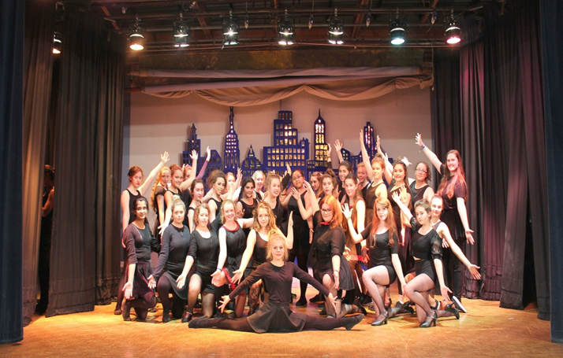
Many students experienced learning situations in addition to their timetabled classes and these have helped enhance their subject knowledge. We acknowledge the work of staff in organising and facilitating opportunities such as:
- Maths Circle
- BT Young Scientist Final
- Science Week activities
- Choir
- Orchestra
- LCVP Mini companies
- Variety Show, involving over half of the full student body
- Irish trip to the Gaeltacht
- Biology Fota Island trip
- Geography Field Trip
- Seachtain na Gaeilge Activities
- Mock Oral exams
- Credit Union
- Primary school science day.
- Primary show Variety Show Matinée

Transition Year
The TYs had another busy year of learning experiences. Ms Frances O’ Callaghan did an excellent job coordinating the myriad of activities. Some of the activities were:
- Ploughing Championship trip with Ms. O’ Callaghan.
- TY Outdoor pursuit trip to Kenmare organised by Ms. Judge
- Community Service and Work Experience organized by Ms. Whalley.
- Drama production with Ms. Murphy and Ms. Reidy.
- The TY Variety Show performance directed by Ms. F. O’ Callaghan and supported by Ms. Aileen O’ Callaghan.
- Trip to the Gaeltacht with Mrs. Roche Cagney and Ms. Higgins.
- Wicked Show in Dublin with Ms. O’ Callaghan.
- CEIST Bake Off in Home economics class.
- Composer in the Classroom

First Transition Year Newsletter published by Ms. Aileen O’ Callaghan: http://www.stalscork.com/wp-content/uploads/2013/03/TY-Newsletter-Summer-2015-small.pdf

Finance:
The school finance is regulated on a daily basis by our Financial Secretary Ms Helen O’ Callaghan and the principal Ms. Long. The transactions follow the directions laid down by the best practice guidelines of the FinancFinancial Support Services Unit (FSSU) of the management body JMB and Budget passed by the Board. The Principal recognises and appreciates the support of Ms. Anna Brennan of FSSU JMB and Ms. Bernadette McKeowan of CEIST throughout the year on all financial matters.

Monthly checks on account balances and the current spend versus the budgeted spend are completed by the Finance Sub Committee of:
Ms. Frances O’ Callaghan
Mr. John Hartnett
An tUasal Seán Ó Broin and
Ms. Richel Long
Proposed reports from the financial sub-committee are ratified at each Board meeting.

Accounts are sent to CEIST for scrutiny and an annual audit is completed by Moore Stephens and Nathan Cork. Audited accounts are sent to CEIST and the JMB for scrutiny. The audited 2014/15 accounts show a small surplus of income over expenditure and the school remains in a healthy financial state.

Ongoing professional development:
Continuing professional development is necessary to keep pace with our changing understanding of education and the changing nature of schooling.

The Board of Management ratified the first Continuous Professional Development (CPD) policy in St. Aloysius, demonstrating their commitment and support to teachers who engage in CPD in their personal time. Each member of staff is encouraged to take responsibility for his/her own learning with the aims of the school taking primary importance.

In school continuous professional development involved the support of The National Educational Psychologist Services and The Special Educational Support Services.

Many staff members availed of professional development opportunities and active membership of subject associations was encouraged. The Board of Management endorses the engagement of many experienced teachers in the correction of practical, oral and written State Examination Commission Leaving and Junior Certificate examinations.

Student Care:
Our regular Student Support team consists of everyone in the school – subject teachers, class teachers, Year Heads, career guidance teacher, learning support teachers, ancillary staff, student leaders, Deputy Principal, and Principal.

In addition there was a focus this year on Student Mental Health with our successful application for an Amber Flag in recognition of work in Mental Health.

Information Technology:
100 MB Broadband is now in place. Additional computers were provided on the third floor computer room. Repair and maintenance of data projectors was prioritised was heavily invested into. Teachers have reported a greater use of ICT in their teaching
following the introduction of teacher based classrooms.

Pastoral Care
Pastoral Care is an integral part of our mission in St. Aloysius Secondary School and as such requires a formal structure to ensure its effectiveness in our school community on a day by day basis and particularly at critical times. In St. Aloysius we believe that Pastoral Care permeates all aspects of school life.
Class Teacher:
The class teacher is the first and most frequent contact person for each student and is often best-placed person to have a sense of a student’s well-being. Each class group has a designated teacher who takes a special interest in the appointed class. As well as monitoring attendance and behaviour, the class teacher also takes a pastoral interest in each girl and as far as possible tries to be aware of the general welfare and progress of each student in the class. Each girl’s class teacher is a source of immediate support and especially so for 1st year students as they make the transition from primary to secondary school. She will consult as necessary with each subject teacher to alleviate any source of difficulty.

Year Head:
The classes that belong to a particular year group are under the care of a Year Head who monitors student progress and behaviour in that particular year group as well as the general welfare of each individual. The Year Head will liaise with subject teachers and class teachers to ensure the student is reaching her academic and social development potential. Year Heads meet with the Deputy Principal and Principal at Year Head meetings. Information from these meetings is to be disseminated by Year Heads to class teachers.

Learning Support and Resource Teaching:
Every teacher teaches every student in St. Aloysius. All teachers are committed to students who have additional educational requirements. Students with special educational needs are welcome. Education in the Mercy Tradition is committed to holistic development and to the achievement of the full potential of each student. All teachers aim to prepare students by academic and practical training for adult living and to promote in them a co-operative spirit so that they can make a constructive contribution to society.

Guidance Counsellor:
The school Counsellor is responsible for the planning and implementation of the school guidance programme. Ms. Whalley provides support to students in connection with their educational, social and personal development and adjustment.

During an interview, counsellors create a confidential atmosphere, in which the student can have the confidence to seek advice.

As well as personal interviews Counsellors also take formal classes with students to give career information. In the process the Counsellors guide pupils to make their own career choices based on self-understanding and self-knowledge.

Curriculum:
The school follows the Department of Education & Science programme for secondary schools in preparing students for the Junior & Leaving Certificate Examinations. Junior Cycle:
First Year: The present policy in the school is that all first, second and third year students take: 8 compulsory exam subjects: Irish, English, Mathematics, French/German, History, Geography, and CSPE.
3 optional subjects chosen from: Art, Business Studies, Home Economics, Science and Music.
3 non examination subjects: Religion, SPHE and PE

Transition Year: This is an optional non-exam one year course of studies which is designed to help students broaden their interests and widen their educational experience. Subjects and learning activities are reviewed annually by the Board of Studies and may include: Irish, English, Mathematics, Enterprise Studies, Science, French and German, Career Guidance, Home Economics, Physical Education Religion Education, Music, S.P.H.E., Art, Craft & Design, Preparation for Work, Work Experience.
The T.Y programme also includes trips of educational and social value and can vary in length from half day, full day, and three trip to Kenmare.

Leaving Certificate:
Students in 5th and 6th year take 4 compulsory exam subjects: Irish, English, Mathematics, French/German, and 3 optional subjects chosen from:
Home Economics, Business Studies, Accounting, Business, Art, Geography, History, Music, Physics, Biology and Chemistry.

This Annual report is a snapshot of our school life and our school year. It represents the busy school life and offers a glimpse of the myriad of activities that occur throughout the school year.

We are presenting the Annual Report in this new format this year and we hope to extend it in future years. We are proud of our school and we encourage all the school community to actively engage in events, embrace new opportunities and add to the life of our school. We’ve had many wonderful occasions and we have celebrated many wonderful attainments and achievements.

I wish to thank all our students and parents for their contribution to school life. I thank all who have taken on leadership roles as members of our support teams – Class Prefects and Vice Prefects, Meitheal, Student Council, Parents’ Association, Board of Studies, Year Heads, Class Teachers, Student Support team, Deputy Principal and Board of Management.

I particularly wish to thank our ancillary and teaching staff for their commitment, dedication and professionalism. Every event contained in this report and other learning opportunities that occurred during the year was steered by the hand of a teacher and supported by many others.

I pray that everyone in the school community will continue to be blessed as we embark on a new school year. Ms. Richel Long, November 2015

