St. Aloysius Secondary School

Sharman Crawford Street, Cork.
Roll Number: 62630J

1. Principal’s Message
St Aloysius Secondary School is a school with a multicultural, socially diverse and geographically dispersed student population. St Aloysius provides equal opportunity for all students to achieve excellence in academic, cultural, sporting, civic, leadership and social endeavours, in an inclusive environment that supports learning, teaching and friendship. The school is committed to fostering Christian values and mutual respect in a caring environment.
Our school provides for the academic, spiritual, social, personal and physical development of the individual.

I confirm that information in this report is the result of a combination of the Department of Education and Skills self‐evaluation process and the input of all our school partners. I hope this Annual Report is a balanced account of the school’s achievements and areas for improvement or development.
Ms. Richel Long

2. School Development Planning
Priority Areas selected for the School Year 2013 – 2014
The final agreed priorities for the school year 2013-2014 were:
1. Literacy School Improvement Plan: Literacy School Improvement Plan: The Literacy School Improvement Plan concentrated on students reading for pleasure. A focus group of teachers from varying subject backgrounds formed the Literacy Team.
They gathered data from student surveys, questionnaires, assessments with specific literacy areas targeted.
All of the data gathered was analysed and various areas of strengths and challenges were identified. Targets for improvement were then set and methods to bring about those improvements were formalised. The Literacy School Improvement Plan was presented to all staff in May 2014 and will be enacted in the school year 2014/15. The Literacy School Improvement Plan is now available on our website – www.stalscork.com/schoolselfevaluation.
2. Revival of the Library: It has been a very successful year for our school library. Thanks to the Past pupils Union’s (PPU) generous contribution, new books were purchased during the summer. The recent “Book Drive”, which was organised by the English department and superbly supported by the Student Council, has greatly increased our stock with the addition of 300 new titles. During the past academic year, students have availed of many new exciting titles. Our Read walls show the wide range of novels that interest our students. Reading for enjoyment has been part of the Literacy target this year- our aim is to foster a love of reading. 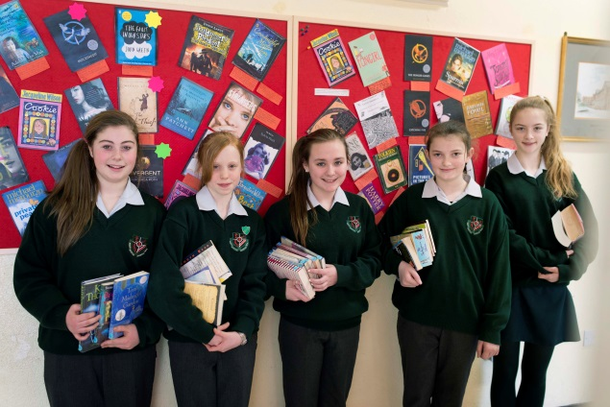

2. Transition Year Curriculum: The Board of Studies developed a transition year curriculum that would maximise the student’s exposure to all three science subjects and increased maths, English and Irish lessons to five periods a week.
Students continue to explore topics that are external to the leaving and junior certificate syllabuses. Students are assessed on project and competition submissions. Student and parental feedback is positive regarding the change. Subjects such as business/enterprise have been reduced from four to two periods, as has physical education.
It was decided to continue to concentrate on the area of maximising student involvement in various activities and excursions thus continuing to provide a comprehensive curriculum.
3. Anti-Bullying Policy: The existing anti-Bullying Policy was reviewed and updated in line with the new Department of Education & Skills Guidelines and was approved by the various partners of the school community.
Staff attended In-Service in the following areas:
Literacy,
School Self Evaluation,
Junior Cycle Framework,
ICT,
Business Teachers Annual Conference,
German Teachers Annual Conference,
Modern Languages,
Guidance Counsellors Annual Conference,
JMB, Education Conference on New Junior Cycle Framework,
JMB, Annual Conference,
JMB, Allocations workshop,
Child Protection,
JMB Training for Newly Appointed Principals – Phase 1 and Phase 2
CEIST Training for Newly Appointed Principals.

3. Special Needs Education

We continued to provide ongoing support for students with Special Educational Needs. This was done through providing extra class divides in some subjects, withdrawing students from class either individually or in small groups and by the use of team teaching. Application was made to the Special Education Needs Organisor for resource hours and/or assistive technology as the need arose. Applications were submitted to the State Examinations Commission for Reasonable Accommodations for students sitting State Examinations. Applications were submitted to the National Educational Psychological Service (NEPS) for Educational Psychological Assessments for students identified as requiring assessment and a number of students were assessed or had assessments reviewed during the year.

4. Faith Development:

RE Provision/hours taught in each year.

All class groups were timetabled for 3 class periods, 2 hours per week for Religious Education.

Observance of Liturgical Year
Prayer services for the Holy Souls were held during November.
All year groups attended an Advent Prayer service in the local church during December.
4th year students help to set up the Crib and Advent Wreath each year.
A Christmas Carol service is held annually.
All students had an opportunity to attend confession during Lent.

Culture of prayer and sacramental life in the school
Masses for the opening of the new school year were celebrated in October in the local church with separate masses for junior and senior students.
Mercy Day was celebrated in September. The sisters from the local Mercy Community were invited to the school to attend a prayer service presented by a 1st year class.
A presentation was made to the sisters by the student council.
A graduation mass for 6th years was held in May with parents also in attendance.
Students were involved in a variety of fundraising activities for various charities throughout the year including the following:
St. Vincent de Paul,
Share
Aware
Childline,
Trocaire,
Giving Tree
Crumlin Childrens Hospital,
Jack and Jill Foundation.

- SHARE – This is an organisation which helps Cork’s elderly. Two students, Cliona O’Brien and Aisling O’Sullivan, represented the school on the SHARE executive and they were part of a group invited to Aras an Uachtarain to meet President Michael D. Higgins in recognition of this work.
- Meitheal Team –Students from the year were selected to be part of a team which offered support and organised activities for the incoming First Years.

Catholic Schools week was marked by all class groups participating in a prayer service within their timetabled RE classes and a whole school assembly.

All staff meetings, Board of Management meetings, Parent Association meetings and year group assemblies began with a prayer.
Chaplaincy services
The local Priest, Fr. Michael Lynn, from the Augustine Church, Cork acts as unofficial Chaplain support to the school and he is always available and willing to help when required.
Ongoing professional development
The Principal and Deputy Principal attended the CEIST Annual Conference in Athlone.

5. Student’s experiences in St Aloysius
1. Leaving Certificate results 2013: 45% Progression rate to National University of Ireland colleges. One student obtained 600 points and J.P MacManus Scholarship. 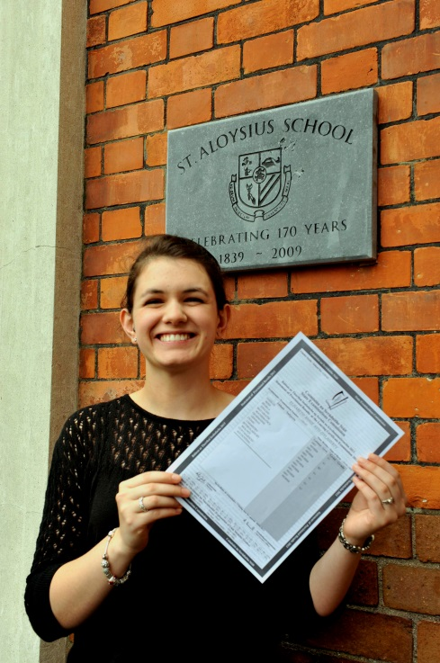
2. The Maths Circle is an initiative from the School of Mathematical Sciences in U.C.C. aimed at students who are above average and gifted at maths. This was the third year of Maths Circles in St. Aloysius. Students from 1st and 2nd year were invited to attend on Thursday afternoons after school from February to April, a total of 6 weeks. A record number of students participated in this programme.

3. Roinn na Gaeilge: Cúpla buaicphointe 2013-14 D’éirigh thar barr le seachtain na Gaeilge arís i mbliana. Bhain gach éinne spraoi as an gcéilí mór tráthnóna Aoine, 14 Márta. Tá caighdeán an rince ag dul i bhfeabhas ó bhliain go bliain, gan trácht ar an amhránaíocht! Bhí na hiontrálacha don chomórtas postaeir a reachtaíodh le linn na seachtaine sin ar ardchaighdeán chomh maith.
Chuaigh lucht idirbhliana siar go Corca Dhuibhne ar an 16 Bealtaine. Stop siad sa Daingean chun féachaint ar fhuinneoga daite Harry Clarke sa séipéal ansan, agus chun cuairt a thabhairt ar an uisceadán, Saol Fo Thoinn. Ar na suíomhanna eile ar thug siad cuairt orthu bhí Séipéilín Galarus agus Ionad an Bhlascaoid. Bhí gach éinne an-sásta leis an lá.
Iarracht eile gur éirigh go maith leis i mbliana ná comórtas a reachtaíodh sa chéad bhliain do ‘Gaeilgeoir na Míosa’. Tuigtear dúinn gur deineadh an-iarrachtaí ar fad – go háirithe i dtreo dheireadh na míosa – le go mbuafaí an duais bheag agus an teastas a bhí ann don bhuaiteoir.
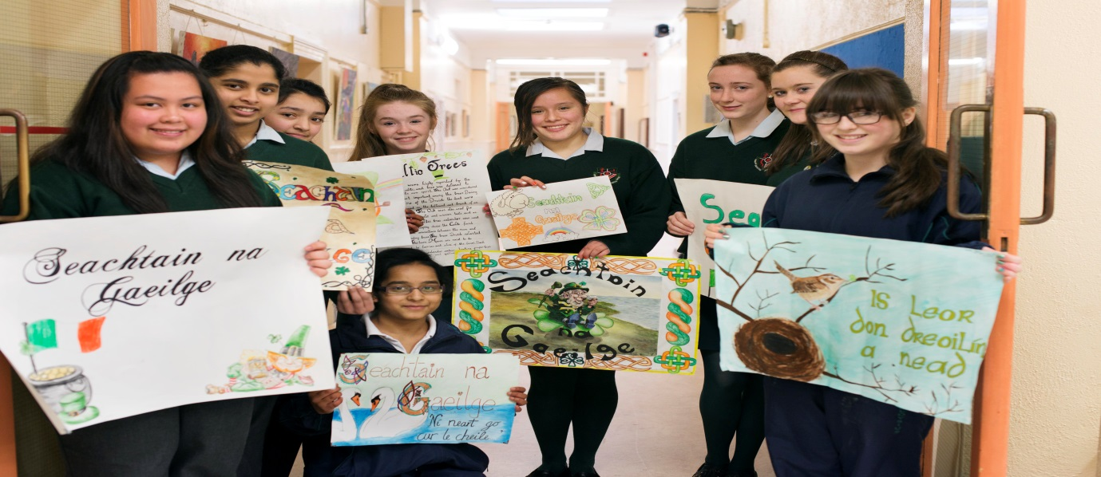

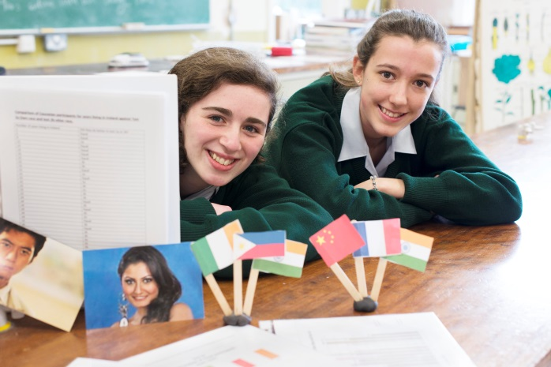

4. BT Young Scientist Competition: This year St. Aloysius were incredibly successful at the Young Scientist competition. Five projects were accepted to compete at the RDS in January with one being awarded highly commended. The titles are as follows:

1. Wind vs. Stringed Instruments and the Gabor Limit
2. How fresh are your eggs?
3. Reverse Engineering a Domino Fall
4. Facial recognition and the Cross Race Effect
5. A mathematical analysis of the lute of Pythagoras.

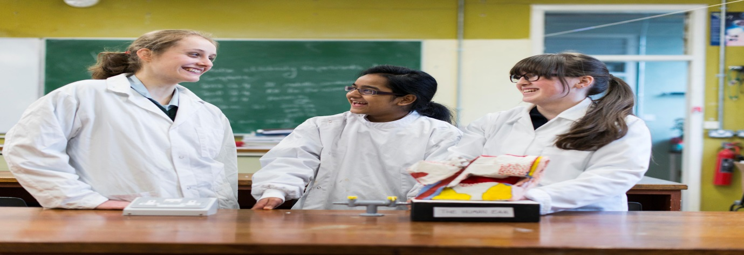

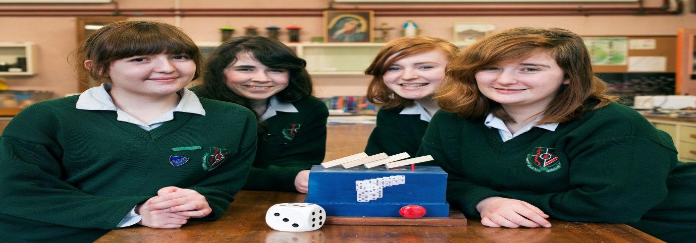
Amber Flag / Mental Health
Students were awarded the first Amber Flags that was rolled out nationwide in
a ceremony on 8th May at Rochestown Park Hotel hosted by Suicide Aware. Students were awarded the flag based on their tireless and enthusiastic work to promote positive mental health in the school community over the past year.
St Aloysius will now proudly fly the Amber Flag inside the school canteen to show its commitment to students’ wellbeing, and to encourage awareness of all issues which may impact on students’ mental health.
Public Speaking
The St. Aloysius Debating Society had a very successful year. The Society, under the guidance of their Senior Chairs, had very strong teams composed predominantly of 1st and 3rd year students. St. Als hosted two major debates including the annual first year Easter Mace which had a record attendance compared with previous years. St. Als’ teams also entered numerous debates throughout the year with St. Als’ speakers being placed in the top 10 in most debates.
Basketball
The second years were lively, active and participated well in a wide variety of events in the school. In basketball they competed as far as the quarter-finals in the schools competition.
Health Promotion
Healthy Eating and Fitness Week was a joint project of the home economics and P.E department. A variety of activities took place emphasising the importance of local and healthy foods, in addition to exercise and fitness. Visits from local artisan food companies such as Arbutus Bread, Rawbina and Ballycotton Seafood, supported the culinary enterprise component of the senior and transition year programme. The highlight of the week was a visit from the TV Chef Rachel Allen, who spoke to the students on World Home Economics Day.
6. Individual Achievements
1. German Scholarship winner Aleksandra Migliaccio has been awarded a full scholarship by the German government for 4 weeks commencing this summer. The basis of this scholarship is on her excellent results in her Junior Certificate. She will have the opportunity to visit various parts of Germany and also experience family life in Germany. Wir wúnschen ihr gute Reise und viel Spaβ.
2. Cork City Library organise an annual short story completion. In 2014 the number of entries exceeded 450 entries. Shauna Williams’ entry was shortlisted in the top 20.
3. Megan Dollery entered a competition run by Hot Press magazine entitled “My first Green Day concert”. Her entry was shortlisted. Subsequently, she was invited to a reception in Dublin with the judges and the editor of Hot Press.
4. Susan Lagli qualified for the Irish European Union Science Olympiad (IrEUSO) in 2014. Finalists are chosen on the basis of their Junior Certificate Examinations in Maths and Science. Susan attended the annual competition held annually in Dublin City University (DCU).
5. Siming Wang, student of Second Year received a Special Merit award in the Texaco Art Competition. Angela Johnson and Sreelakshmi Selvaraj receiving a Highly Commendation for their individual art pieces which they submitted to the Texaco Art Competition.
6. Ciara Wyse (6th year) took part in the European Karate Championships in Sheffield in October. She did exceptionally well representing Ireland and obtained 3 bronze medals for Fighting, Kata and Team Fighting.

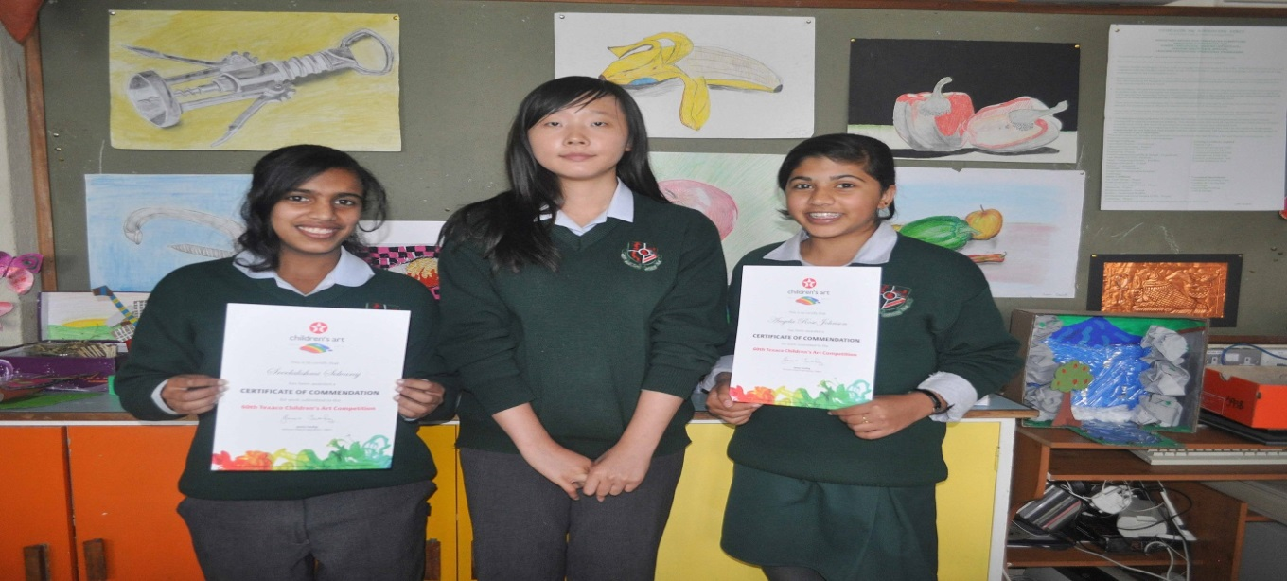
Parents Association:
St Aloysius Parent’s Association
Firstly a big thank you to all the parents who have made this a most successful and active years. We sadly said good bye to Yvonne Bane and welcomed Richel Long as our new Principal. We have enjoyed the support of the Principal on our emphasis of integration and being an integral part of the school community rather than being purely a fund raising organisation. This is not to say we don’t fund raise, through your fantastic efforts the various activities we have undertaken has raised some €1180 towards worthwhile projects within the school.
Integration within the St Aloysius school community will continue to be a priority. We have worked very closely with the Student Council, teachers and extra-curricular groups such as the Debating Society and look forward to developing these ties over the coming years.
Below I’ve summarised some of the wonderful activities we have been involved in during the past year:
We started the year providing refreshments at the school open evening, the cakes you provided were very well received and made an excellent impression on potential student and their parents. Thank you all of you who provided the cakes in response to the text request.
As previous year we organised and ran the refreshments and raffle for the annual concert. We setup a ‘pop-up’ café for the audience as well as providing much needed refreshments for the girls taking part in the concert. We made a whopping €560.20 on the night all thanks to your fantastic cakes and donations. All money made goes to provide vital much needed resources for the school.
The Christmas 2013 Giving Tree for St Vincent de Paul was launched by John Spillane, we didn’t realise just how many teachers were great fans of John (they were able to sing along with every song he sang). In total we were able to donated over 300 presents to SVP to give to Cork children over the Christmas festivals. This was the third time we have run the Giving Tree and each year your generous response and the generosity of the girls is beyond compare, thank you.
In April St Aloysius Debating Society hosted the Cork Inter-schools debate, the PA furnished refreshments and sponsored some of the prizes. There were approx., 50 young people from schools all over Cork at the debate and they certainly tucked into the refreshments while commenting favourable, and in some cases with a degree of envy at the luck of St Als students in having a fantastic canteen facility.
We invited all parents to our April committee meeting to discuss the results of the uniform survey. At the meeting Sinead Murphy from Buckley’s Schoolwear addressed the meeting and presented alternatives to some of the uniform items. In the coming weeks we will be making representation to the School Board of Management on the school uniform.
May the 14th the PA provided support to the school sponsored walk. We were the ‘Lollipop’ guys at the each of the road crossings on the route. In recognition we presented everyone who took part in the walk with an ice cream. A great day and well done to all the girls who raised a fantastic sum of money for the school.
Our school year finished with a Recycling Drive. We collected almost a tonne of used clothes and textiles. Your valiant efforts in de-cluttering raised €627, which will be put to good use in the school.
Well as you can see, a fantastic and busy year was enjoyed by all. If you can spare a little time, imagination and skills to make next year even more successful I look forward to hearing from you.
Stephen Williams
Chairperson St Aloysius Parents Association

7. Student Development:
Awards Day
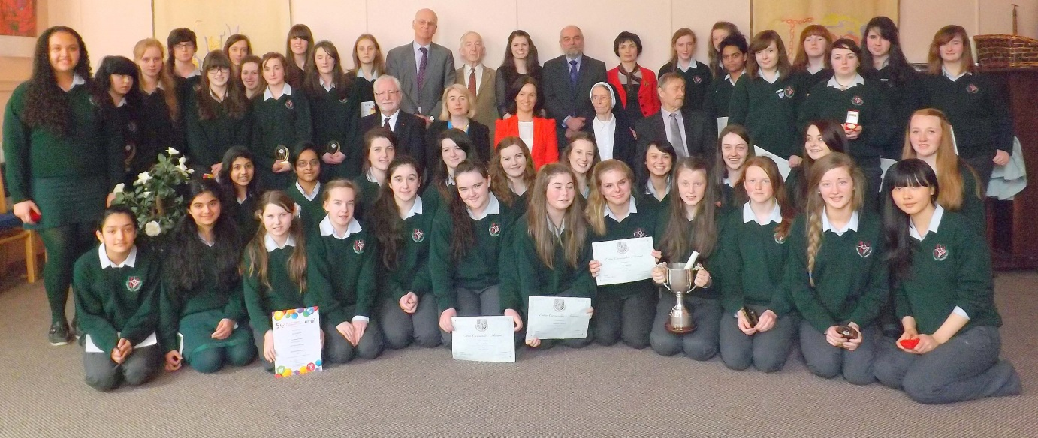
Student Council
The following submission is written by the student council
From the very first meeting of the year, our Student Council has been highly productive in its efforts to improve our school community. In September 2013, our members had the great honour of welcoming Lord Mayor, Councillor Catherine Clancy, to St. Aloysius, on this special occasion, Edel Kavanagh, our Head Girl and Council Chairperson, ably delivered an introductory speech on behalf of the Council.
In October, the Council organised and ran a successful “red and white no uniform day” to raise funds for our school basketball team. The proceeds of this enjoyable occasion contributed to the selection of a stylish new kit. Next on the agenda was the planning of Open Night 2013. Our members undertook meet & greet duties for the occasion, guiding our visitors around the school and providing an insight into the history and tradition of St. Als. We were delighted to hear that the Principal received several letters of thanks and praise from visiting parents with whom we liaised on the night.
The first term ended on a high note with singer John Spillane formally launching our annual St. Vincent de Paul “Giving Tree” campaign. On the 2nd of December, the guitar man with the great voice and big personality entertained us, while Christmas gifts and food hampers poured in for disadvantaged children and families
We began 2014 by welcoming to St. Als our new principal, Ms. Long. Ms. Long has liaised closely with our Council members and welcomed our contributions to policy formation in areas such as Fire Safety, Uniform, and Critical Incident Policy.
In conjunction with the Parents Association, the Council is also heavily involved in the coordination of a clothing recycling drive. The proceeds of this will go towards the further improvement of school facilities and we have high hopes that it will be a fruitful venture.
The Student Council will conclude this academic year by meeting with the Board of Management. We were delighted to accept this invitation and are looking forward to discussing our future plans and projects with the Board.
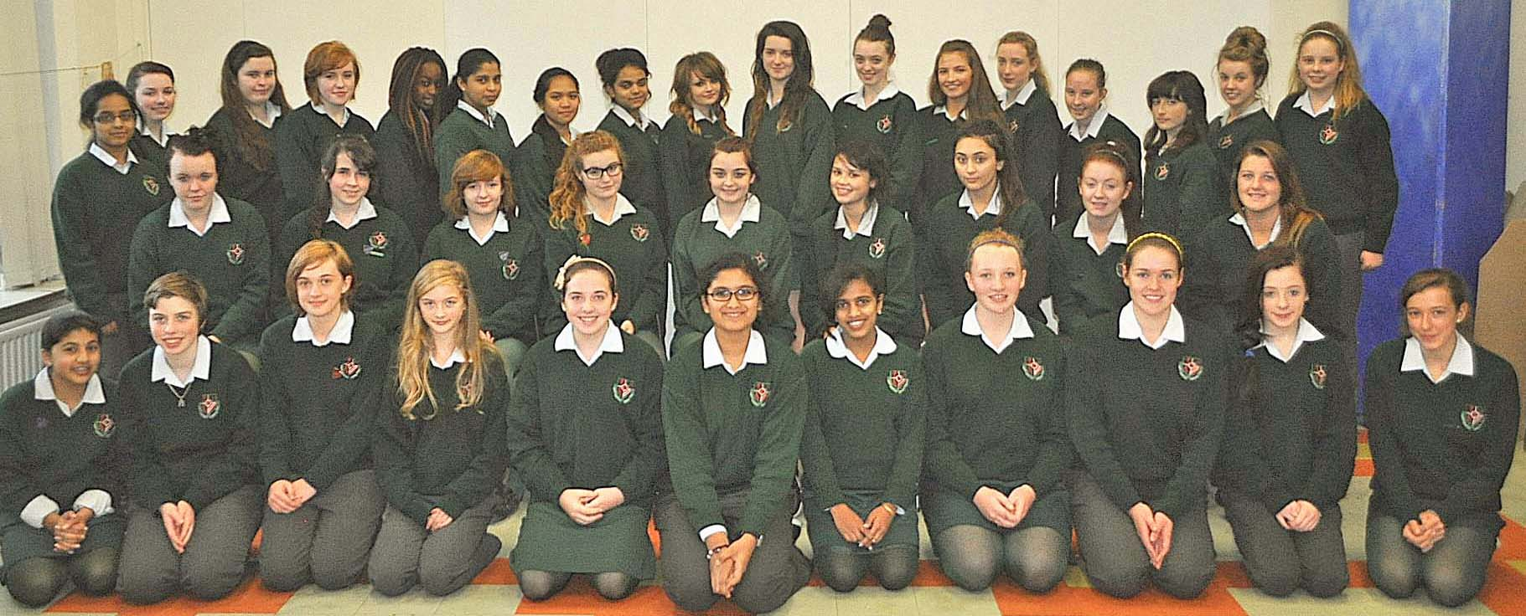
9.Leadership Programmes
The Student Council rounded off the month of October by welcoming representatives from the Cork Rotary Club to St. Als. These guests attended our school to interview three of our members, fifth year students Maria Cordero, Angeline Lagali and Shauna Williams, who participated in Rotary’s Youth Leadership Competition. These students were also among those to attend U.C.C. for a weekend conference, hosted by the International Relations Society, to discuss issues of global concern. The girls thoroughly enjoyed and benefited from this event, and the award for best speaker was won by Edel Kavanagh.
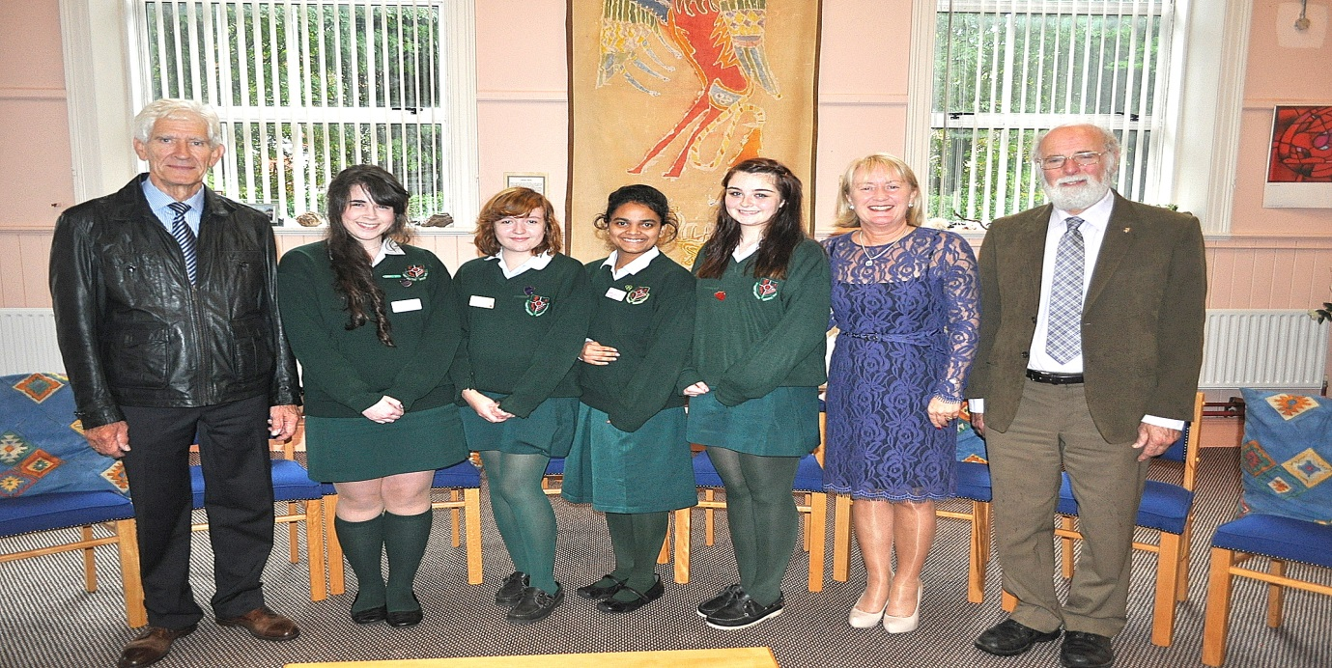

10. Current Enrollment
We are presently in a period of increasing numbers; we continue to attract students from a wide variety of national schools. Our current first year students came from sixteen primary schools. In September 2013 the student numbers was 258 students. Sixty students enrolled in first year in September 2014 while thirty nine students completed their Leaving Certificate exams in June 2013. This trend will continue for another year as our enrolment for September 2015 is sixty students with fifty two students due to complete their Leaving Certificate in June 2015.
11. Financial Overview
School A/C’s to present indicate that school finances are in good order. There was no capital spending this year. Due to Department of Education and Skills cut in student support grant and the student capitation grant we will experience a reduction in our income.
Accordingly we have planned for reduced in expenditure. We in St. Aloysius Secondary School acknowledge the generosity of our parental body, which financially support the school preserving the student services.

This concludes the Annual Report.

